Case 1: Sales Performance Analysis
Company Background
TechSupply Co. is a regional distributor that sells electronics, office supplies, and office furniture to both retail and business customers. Management wants to better understand sales trends, customer purchasing behavior, and regional performance to improve future sales strategies.
You have been hired as a junior data analyst to explore the sales dataset and provide insights. Your task is to use Excel filtering and sorting tools to answer business questions and provide recommendations.
Dataset: use the techsupply_dataset.xlsx
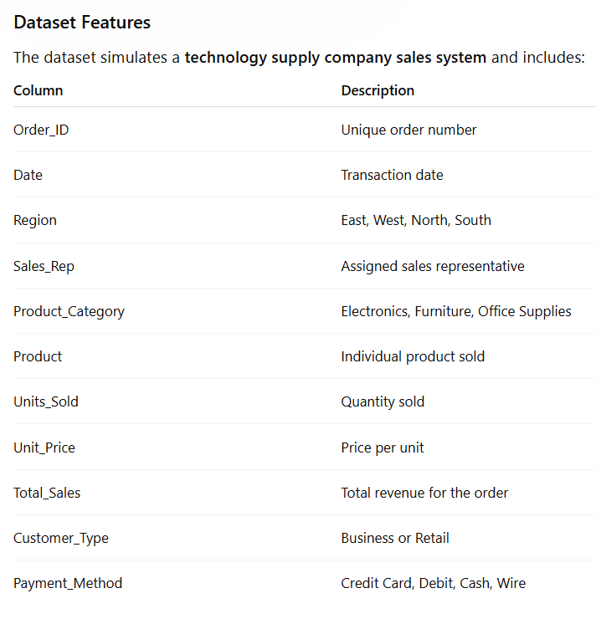

Complete the following 5 tasks.
REGIONAL PERFORMANCE ANALYSIS
Task 1: Use filters to explore sales by region.
- Filter by Region = East
- Sort Total_Sales from Largest to Smallest
Questions:
- What is the largest sale in the East region?
  - Largest sale is 52950.
- Which product category appears most frequently?
  - Electronics
- Which sales representative appears most often?
  - Brown and Johnson tie with 14 sales.
CUSTOMER BEHAVIOR ANALYSIS
Task 2: Filter by
- Customer_Type = Business
Questions
- Which product category do business customers purchase most often?
- Office Suplies
- What is the largest business transaction?
  - 63646,2
- Which sales rep handles the most business orders?
  - Brown and Garcia
PRODUCT PERFORMANCE
Task 3: Use filters to analyze Product_Category.
Analyze each category separately:
- Electronics 75929
- Furniture 631
- Office Supplies
Questions
- Which category appears to generate the highest total sales?
  - Furniture have 1.29M on sales.
- Which specific product appears most frequently?
  - Filing Cabinet, Notebooks and printer paper are tied as the most frequent products.
- Which category tends to have the largest individual transactions?
  - Electronics has the largest single transaction with Lapto
PAYMENT PATTERN ANALYSIS
Task 4: Filter by Payment_Method
Analyze:
- Credit Card
- Debit
- Cash
- Wire
Questions
- Which payment method is used most frequently?
  - Credit card is used most often.
- Do business customers prefer a specific payment type?
  - Business customers use Debit more than other payment methods.
- Which payment type is associated with larger purchases?
  - Wire is largest purchase.
TOP SALES REPRESENTATIVES
Task 5: Sort by:
- Sales_Rep
- Total_Sales(Largset > Smallest)
Questions
- Which sales rep appears to handle high-value transactions?
  - Singh handles the highest value transactions.
- Which rep appears most frequently in the dataset?
  - Brown
- Which region do they appear to sell in most often?
  - Brown sells most often in West Region
ANALYST RECOMMENDATION
Imagine you are presenting your findings to management.
Answer the following:
- Which region appears to be the strongest market?
  - East is the strongest market with 583k on sales.
- Which product category should the company promote more?
  - I think furniture and electronics. They bring the most revenue.
- Are business customers or retail customers more valuable?
  - Retail customers bring more money, so they are more valuable.
- What two recommendations would you give the sales manager?
  - Maybe Singh can give training to other sales persons.

Bonus
Build
- Bar Chart – Sales by Product Category
- Pie Chart – Customer Type Distribution
- Column Chart – Sales by Region
What story does the data tell?

